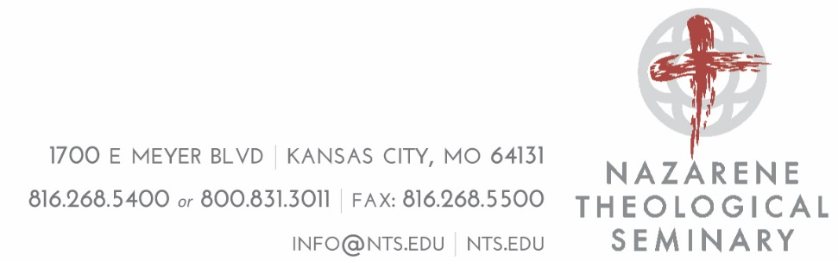

This is the reference form for all students applying to the Doctor of Ministry Program at Nazarene Theological Seminary. The student is required to fill in the first section of the form indicating their name, anticipated start term, and the reference type (Academic; Pastoral/Ecclesial; Personal/Layperson).

The recommender is then to fill out the remainder of the form, taking special notice of the specific questions pertaining to each reference type. If the form needs to be filled out on paper please use a separate piece of paper to answer the questions.

When the reference is complete, the recommender should send it to:
- Email: enroll@nts.edu
- Mail:
Nazarene Theological Seminary
Attn: Admissions
1700 E. Myer Blvd.
Kansas City, MO 64131
- Fax: 816-268-5500

Should any questions arise, the recommender should first ask the applicant for any clarification.
NOTICE: If you are unable to fill out this form (i.e. click in the text boxes to edit text or click “check boxes” to mark them):
- Click on the “VIEW” tab at the top of Word.
- Click “Edit Document.”
- If you are still unable to complete the form, please contact the Office of the Registrar and Admission (enroll@nts.edu or 816-268-5400) for further assistance.

NAZARENE THEOLOGICAL SEMINARY – REFERENCE FORM

Applicant Information
to be completed by the student

Application Type Type of Evaluation Requested (check one)
☒ Doctor of Ministry/Advanced Graduate Certificate ☐ Pastor/Ecclesial Supervisor
☐ Academic Professor
☐ Personal/Layperson in Ministry Setting

Click here to enter text. Click here to enter text.
Name of Applicant Desired Term of Admittance

The Family Education Rights and Privacy Act of 1974 (Buckley Amendment) provides students a right to review their educational records. The law also permits applicants to waive this right, an action that may protect the integrity of recommendations and references. Please indicate your decision to waive or not waive this right by checking the appropriate statement and signing your name on the line below.

☐ I hereby waive my right to examine this reference.
☐ I do not waive my right to examine this reference.

Click here to enter text. Click here to enter a date.
Applicant’s Signature Date

Recommender Information
to be completed by the reference

Name Click here to enter text. Title Click here to enter text.
Church/Organization Click here to enter text.
Address Click here to enter text. City, State, Zip Click here to enter text.
Phone Click here to enter text. Email Click here to enter text.

Please evaluate the applicant in the following areas

FAR FAR
ABOVE ABOVE BELOW BELOW NOT
AVERAGE AVERAGE AVERAGE AVERAGE AVERAGE OBSERVED

Aptitude for Ministry ☐ ☐ ☐ ☐ ☐ ☐
Academic Aptitude ☐ ☐ ☐ ☐ ☐ ☐
Christian Character and Integrity ☐ ☐ ☐ ☐ ☐ ☐
Church Involvement ☐ ☐ ☐ ☐ ☐ ☐
Concern for Others ☐ ☐ ☐ ☐ ☐ ☐
Emotional Stability ☐ ☐ ☐ ☐ ☐ ☐
Financial Responsibility ☐ ☐ ☐ ☐ ☐ ☐
Initiative ☐ ☐ ☐ ☐ ☐ ☐
Interpersonal Skills ☐ ☐ ☐ ☐ ☐ ☐
Leadership ☐ ☐ ☐ ☐ ☐ ☐
Maturity ☐ ☐ ☐ ☐ ☐ ☐
Reliability ☐ ☐ ☐ ☐ ☐ ☐
Work Habits ☐ ☐ ☐ ☐ ☐ ☐

How long have you known the applicant? Click here to enter text.
How well do you know the applicant? ☐ Very Well ☐ Rather well ☐ Casually ☐ Not well
In what capacity? Click here to enter text.

Do you have any concerns about her/his readiness to engage in a doctoral level program of study?
☐ Yes ☐ No ☐ Unsure If yes/unsure, please elaborate Click here to enter text.
Do you know of any physical, mental or emotional problems that might hinder effective work in Christian ministry? ☐ Yes ☐ No
If yes, please elaborate Click here to enter text.
Additional Comments (attach letter if desired)
Click here to enter text.

Additional Reference Questions by Reference Type
Ecclesial Supervisor Reference Specific Questions
How would the applicant’s participation in a DMin program positively or negatively affect her/his current ministry?
Click here to enter text.

Has this person been effectively active in the work of the church?
Click here to enter text.
Taking into account the current ministry responsibilities of the applicant and the requirements for the NTS Doctor of Ministry program, I (select one) ☐ approve ☐ do not approve this applicant for admission to the program.
Academic Reference Specific Questions
How well did the applicant perform in the classroom setting, in doing research, and in writing?
Click here to enter text.
Do you believe that this applicant is academically ready to undertake the course work required for a Doctor of Ministry program?
Click here to enter text.
Personal/Layperson Reference Specific Questions
What is your experience of the applicant’s character, interpersonal skills, and ministry effectiveness?
Click here to enter text.

How would the applicant’s participation in a DMin program positively or negatively affect her/his current ministry and current life situation?
Click here to enter text.

All References:
Overall Recommendation – All Applicants
The recommendation you give this applicant for admission to Nazarene Theological Seminary
☐ Highly recommend ☐ Recommend ☐ Recommend with reservations ☐ Do not recommend

Recommender’s Certification and Signature

I certify that all information given on this recommendation is complete and accurate.

Signature: Click here to enter text.
Date: Click here to enter a date.

